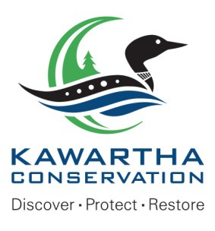

KAWARTHA CONSERVATION
277 Kenrei Road,
PROPERTY INFORMATION REQUEST
Lindsay, ON K9V 4R1
705.328.2271
KawarthaConservation.com

Owner:  Name: | Telephone:
Street: | Cell Phone:
City: | Postal Code:
Email:

Applicant/Inquirer:  Name: | Telephone:
Street: | Cell Phone:
City: | Postal Code:
Email:
Location of Subject Property:
Municipal Address:
Municipality:
Tax Roll Number:
What type of property is this?

Single lot residential or agricultural ($275) Multiple residential / commercial / industrial / institutional ($1,100)

Describe Proposed Work/Activity:
Please describe any proposed work/activity (e.g. construction of a new residential dwelling, grading or filling, shoreline works, etc.)

Is a site visit requested (additional fee will apply)? Yes No

Do we have authorization from the property owner to enter the property for a site visit? Yes No

I, declare that the information provided is accurate to the best of my knowledge. By signing this application, I agree to allow KRCA staff to enter onto the subject property as part of the review process, except if this is an inquiry for an offer to purchase.

Print Name:

Signature: Date:

PLEASE NOTE: INFORMATION YOU PROVIDE ON THIS FORM IS COLLECTED BY KAWARTHA CONSERVATION IN ACCORDANCE WITH THE Municipal Freedom of Information and Privacy Protection Act (MFIPPA) AND WILL NOT BE USED FOR ANY PURPOSE OTHER THAN THAT IS NECESSARY TO PROCESS YOUR REQUEST FOR INFORMATION.

